EXPT NO:7B | DATA VISUALIZATION USING TABLEAU

AIM:

To import, transform, analyze, and visualize the AI Impact on Jobs 2030 dataset using Tableau Desktop and create interactive dashboards and reports to understand AI replacement risk, job demand, automation levels, salary trends, and employment patterns.

ALGORITHM:

1. Start.

2. Open Tableau Desktop

3. Connect to the AI Impact on Jobs 2030 dataset

4. Import and check the data.

5. Clean and transform the data if required by handling missing values, duplicate records, and incorrect data types.

6. Create worksheets using suitable fields such as Job Title, Industry, Country, Education Level, Years of Experience, Future Demand Score, Average Salary, Automation Level, AI Tool Usage, Job Growth 2030, Hiring Trend 2026, and AI Replacement Risk

7. Create visualizations such as bar charts, line charts, pie charts, scatter plots, and tables to analyze the data.

8.Stop

OUTPUT:
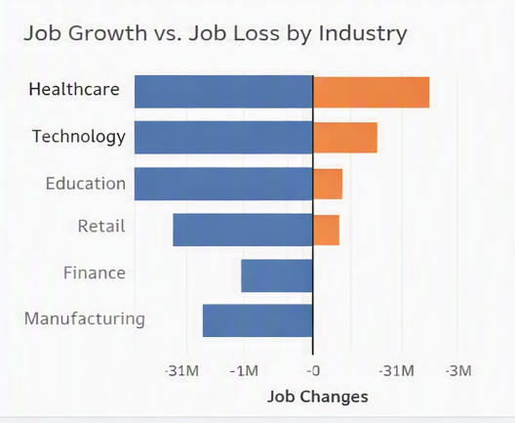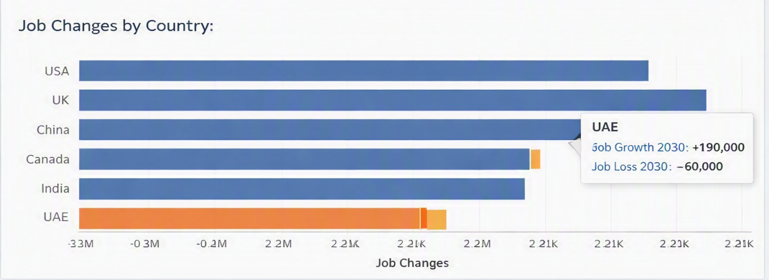

RESULT:
Thus, the AI Impact on Jobs 2030 dataset was successfully imported, transformed, analyzed, and visualized using Tableau Desktop, and an interactive dashboard was created to identify important patterns related to AI replacement risk, automation levels, job demand, salary trends, experience, and employment characteristics.

